8 BIT MULTIPLICATION

EXPNO 3:

AIM : To write an assembly language program to implement 8 bit multiplication using 8085 processor

ALGORITHM:

1. Start the program by loading the first data into the accumulator.
2. Move the data to a register.
3. Get the second data and load into the accumulator.
4. Add the two register content.
5. Check for carry.
6. Store the value of sum and carry in the memory location.
7. Halt

PROGRAM

LDA 8500

MOV B,A

LDA 8501

MOV C,A

CPI OO

JZ LOOP

XRA A

LOOP1: ADD B

DCR C

JZ LOOP

JMP LOOP1

LOOP: STA 8502

RST 1

INPUT:

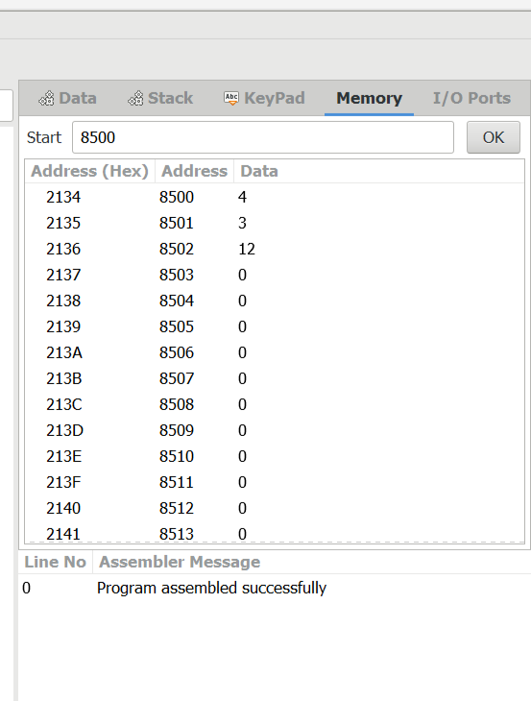

OUTPUT:

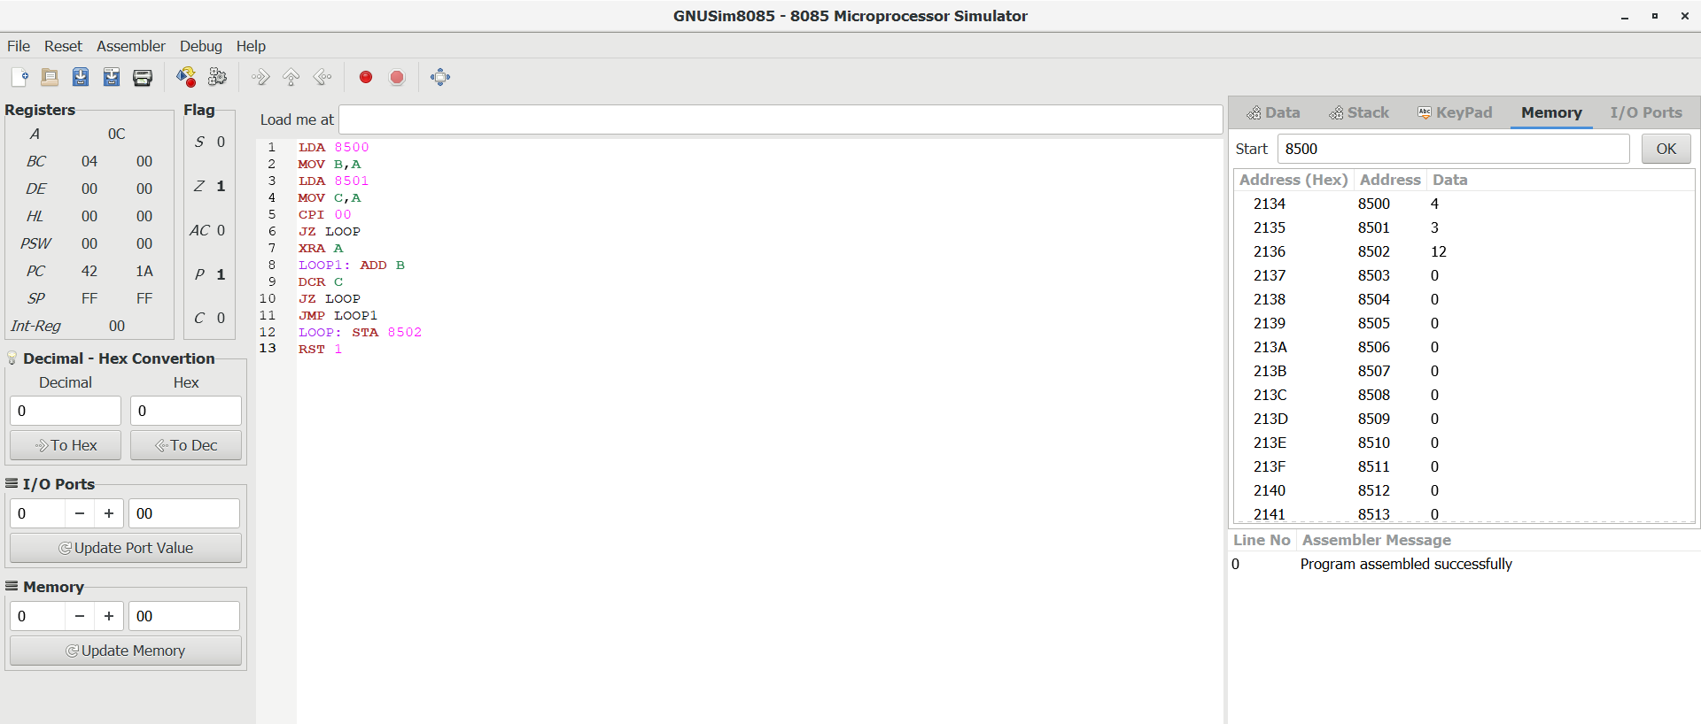

RESULT : Thus the program was executed successfully using 8085 processor.